**ACTIVITY-01**

**PROVIDED EDUCATIONAL ASSISTANCE FOR SCHOOL CHILDREN TO SECURE GOOD ACADEMIC RESULTS**

**ACTIVITY DETAILS**

|  |  |  |
| --- | --- | --- |
| Activity Head | : | Helping local school to achieve and enhance their enrolment in higher/technical/vocational education. |
| Total Duration Spent | : | 2 Weeks |
| Activity Place | : | Govt. Junior Primary School, Mysuru |

**ABSTRACT**

The goal of education is the advancement of knowledge and the dissemination of truth. The activity was conducted in order to encourage and help the students of local schools to achieve good results. It was conducted for the duration of fourteen days, where in each day was dedicated in teaching the students about various topics relating to their academics. Single topic for each day was followed. All the topics were explained by showing the related videos to the students so that they can visualize and understand in a better way. At the end of each topic, questions relating to the topic taught were asked. Along with which the physical activities were conducted. The students eagerly participated in all the activities. This is one of the biggest reasons why parents strive to make their kids attend school as long as possible. It is also why nations work toward promoting easier access to education for both children and adults. Education is an important tool which is very useful in everybody’s life.

**JUSTICIFICATION**

Proper education improves people’s understanding of the world around them, making them less susceptible to influencers of others. Proper interpretation of information requires education, as it improves knowledge. An educated person better understands their own and other’s purpose in society and their rights. Education helps eradicate poverty and hunger, giving people the chance at better lives. This is one of the biggest reasons why parents strive to make their kids attend school as long as possible. It is also why nations work toward promoting easier access to education for both children and adults. Education is an important tool which is very useful in everybody’s life.

**Week-1**

**Day1**

Initially, I decided the topic as, “Helping a local school to achieve good result and enhance their enrolment in higher/technical education”. After the selection of topic, I started searching about the place which would be comfortable for our transportation and decided the school to conduct the activity and thought for which age group students must attend the session.

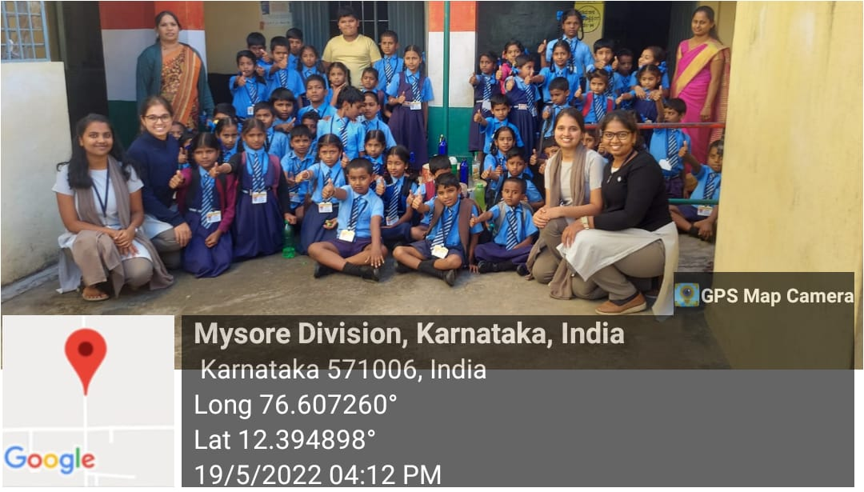

Fig: Visited local school in Mysuru

**Day2**

Seeking permission for conducting the activity. We visited the school to seek permission from the Head Master for conducting the classes and they assigned us particular dates to take classes, so that their academic curriculum not get distract.

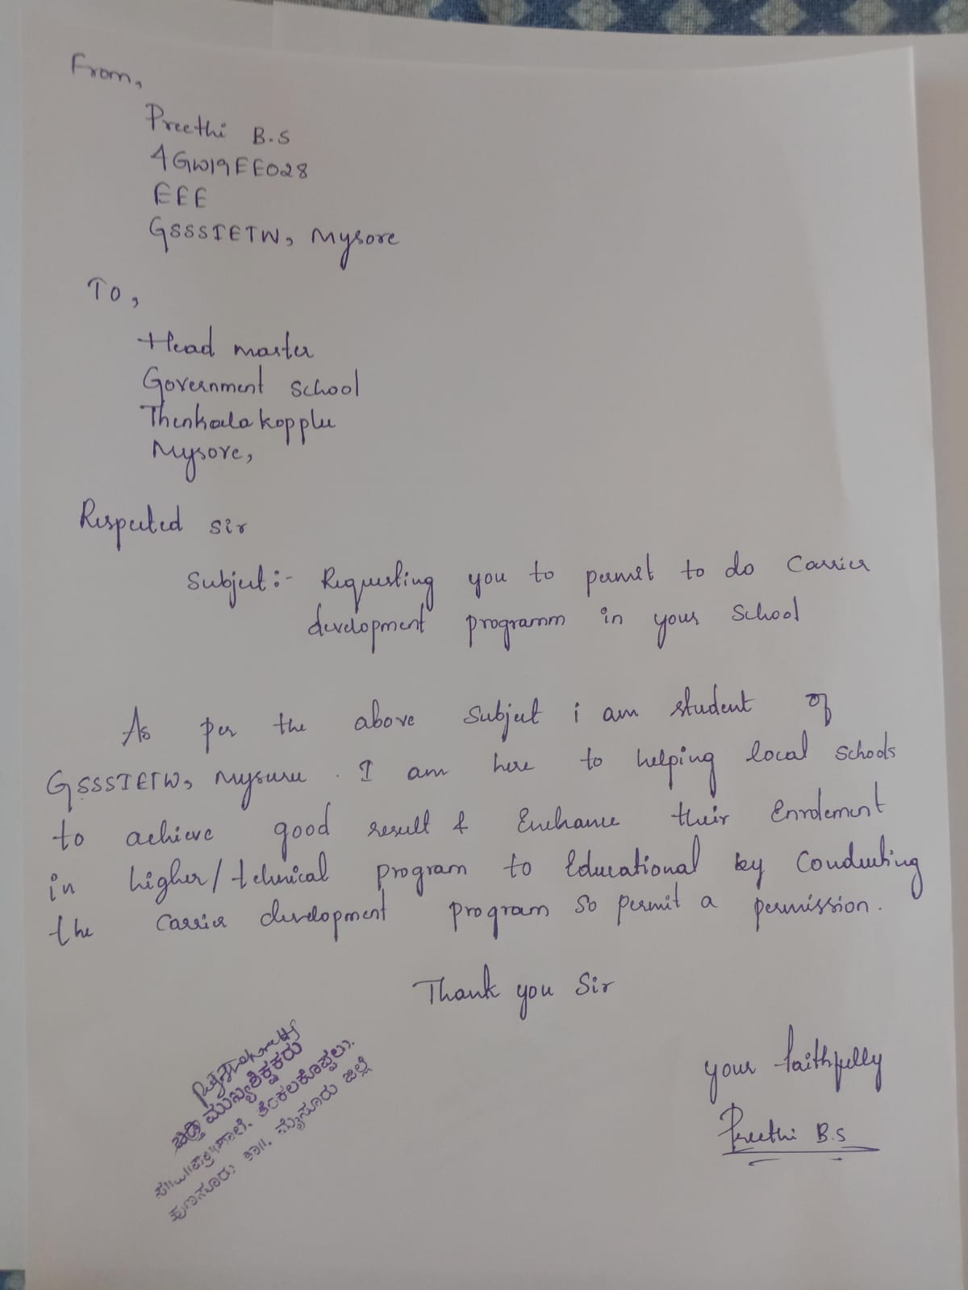

**Day3**

Introduction of the class. We started the class with the introduction and gave them chance to introduce themselves too. We had a casual talk, regarding their studies and curriculum. Then, I took over the class with aim, objective and goals of the session.

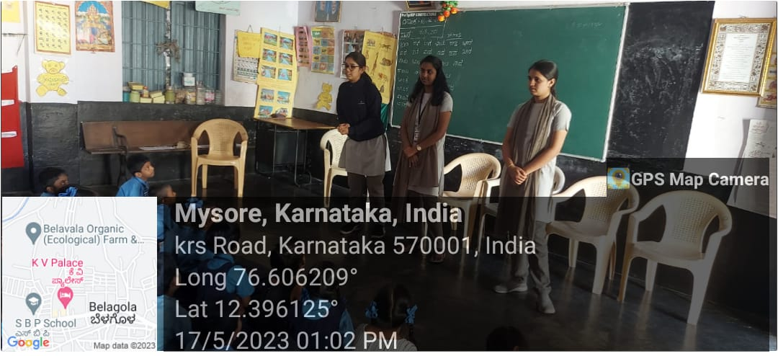Fig: Interaction with students

**Day4**

**Water Conservation Was Discussed**: Conserving water is important because it keeps water pure and clean while protecting the environment. Conserving water means using our water supply wisely and be responsible. As every individual depends on water for livelihood, we must learn how to keep our limited supply of water pure. <https://youtube.com/watch?v=uBMPp0m4-L4&feature=share>

**Day5**

A vocabulary, usually developed with age, serves as a use fundamental tool for knowledge. Acquiring an extensive vocabulary is one of the challenges in learning a language. We included games like Chinese whisper, building words, memory testing, Hang-Man, Puzzle Word, etc. This made me beneficial to get attention and curiosity for upcoming classes.

**Day6**

Talk on “Boost your Self- Confident”. Self-Confidence is a person’s belief or truth in their own ability. The causes of low self-esteem are, ongoing stressful life event such as relationship breakdown or financial trouble. So, the session had a talk on; How to boost one’s self-confidence, what are the causes for low self-esteem and the ways to overcome those causes. As it is very important in everyone’s life, I hope this session helped them a lot.

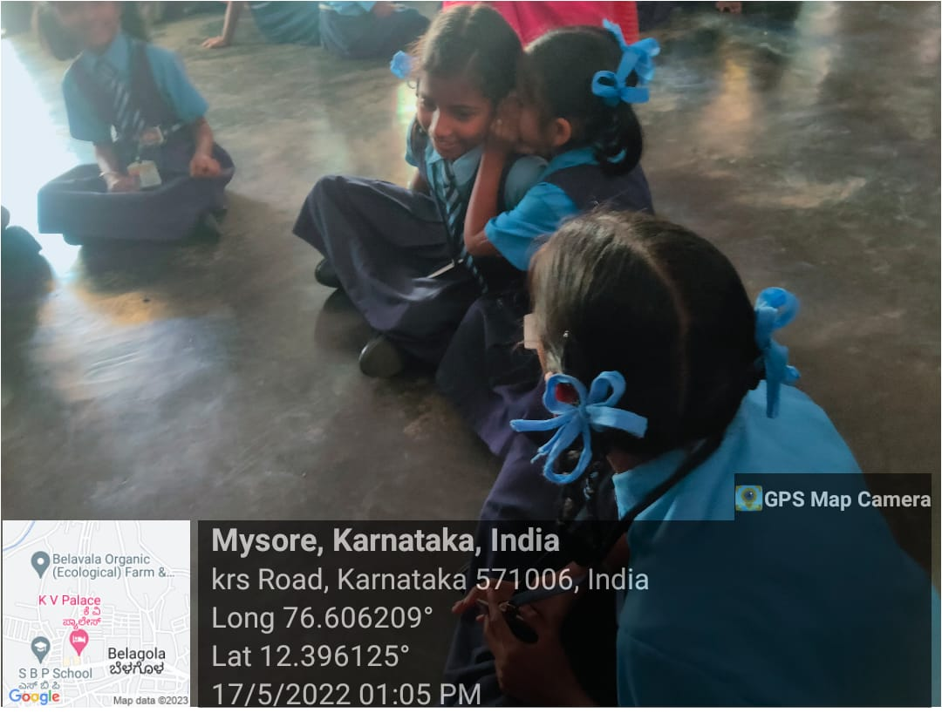

Fig: conducted activities to build confidence

**Day7**

Healthy habits help children grow up happy and healthy as well as contribute to preventing future health problems. For the reasons, we will focus on the 3 pillars of a healthy lifestyle: a balanced diet, physical exercise and personal hygiene. Students were encouraged to follow healthy habits. <https://youtube.com/watch?v=G0abusxAxS8&feature=share>

**Week-02**

**Day8**

This session included topics regarding Body language, Creativity, Attitude, etc. Body language is important that it assists us in understanding and decoding what the person is saying. Creativity opens the mind and it allows us to view and solve problems more openly and with innovation. And, Attitude can influence your ability to move through the world. This session helped them to innovate within the constraints defined by the box.

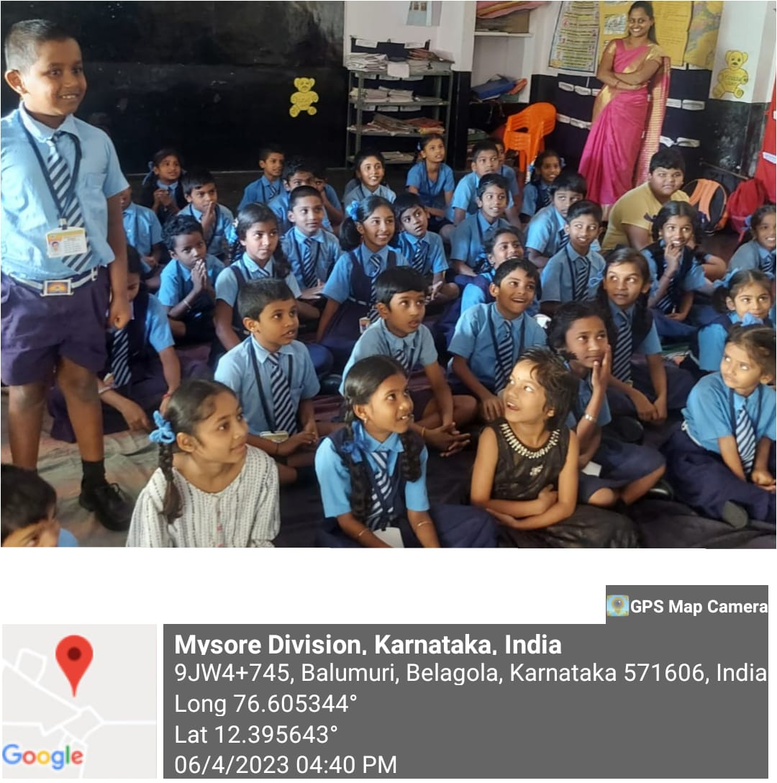

Fig: conducted soft skill session

**Day9**

Study habits help students make their studies easier to understand and make their learning experience comfortable and enjoyable. Having good study habits are important for a student because it will help them to improve their academic learning and skills. Good study habits are the tool to success and hence it was taught. <https://youtu.be/e3aL0OYx0jc>

**Day10**

English language plays an essential role in our lives as it helps in communication. It is the main language for studying any subject all over the world. English is important for students as it broadens their minds, develops emotional skills, improve the quality of life by providing job opportunities. Hence the English alphabets were taught.

**Day11**

Technology affects the way individuals communicate, learn, and think. Technology plays an important role in society today. It can provide empowerment, knowledge, awareness, access and community. As we develop the technology of the future, we can work towards creating a better world long term. <https://youtu.be/iW9M7YywOLA>

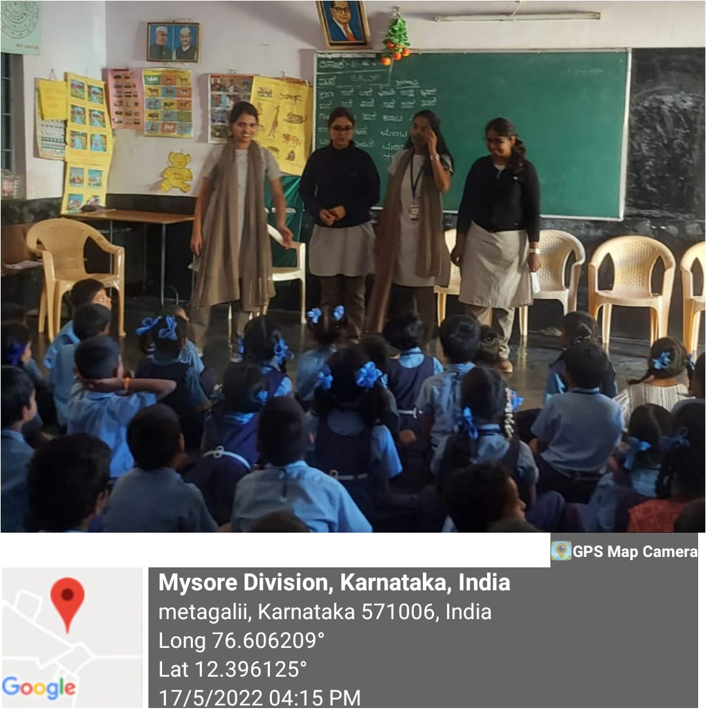

Fig: Interaction with Students about technology

**Day12**

Anatomy is the branch of science that investigates organs, bones, structures, and cells that exist in animals and people. There is a related scientific discipline called physiology, which helps us to understand the functions of different parts of the body. Human anatomy was briefed. <https://youtube.com/watch?v=J1jMfiXXWW8&feature=share>

**Day13**

The Solar System is the system of the sun and the objects that orbit it. It includes the planets and their moons as well as numerous asteroids and comets. These objects are all held in orbit around the sun by the sun’s strong gravity. The eight known planets were explained with the solar system explanation. <https://youtu.be/pnmKcAWd3wA>

**Day14**

Motivating the students to educate themselves and contribute to the nation’s growth was the intention behind the talk. Students were encouraged to speak about their opinion. Suggestions were given to improve their ideas. At last, we interacted with the Head Mistress of the school and thanked her for providing the opportunity to conduct the activity.

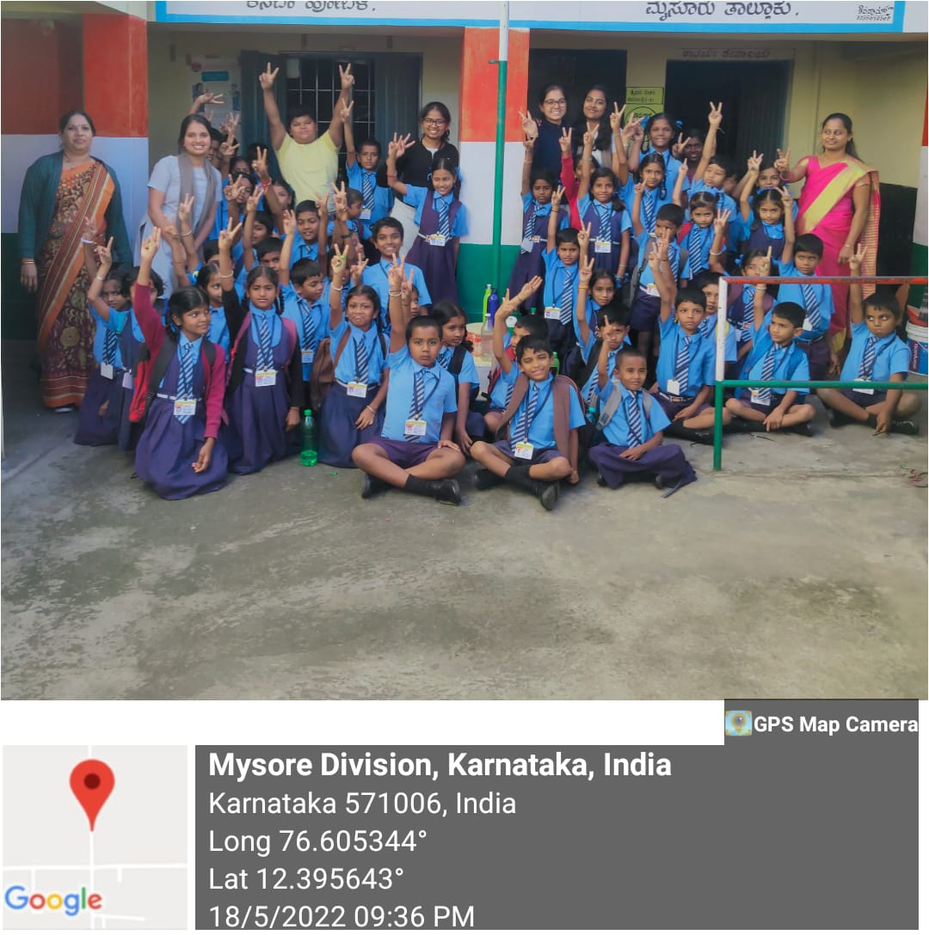

**Activity Experience**

* This activity conducted under the AICTE programme, was a meaningful and fruitful activity.
* We learnt how to work as a team and even conduct event in a local area.
* We spent a quality time with the children , and also tried to fulfil their small wishes which also made us happy.
* Helping orphanages and orphans can promote health, literacy, education, and children’s empowerment. When you help an orphanage, you can say that you have “transformed the world and made a positive impact on people’s lives.

**OUTCOME**

The main purpose of education is the integral development of a person. First of all, education gives the ability to read and write to anyone. A good education is extremely essential for everyone to grow and succeed in life. Education increases self-confidence and assists in developing the personality of a person. Education is a powerful agent of change, and improves health and livelihoods, contributes to social stability and drives long-term economic growth. Education can contribute to the betterment of society as a whole.

.